Project Design Phase Problem – Solution Fit Template

Date

Team ID

Project Name

23 june 2025

LTVIP2025TMID49805

Visualizing Housing Market Trends An Analysis of Sale Prices and Features using Tableau



Maximum Marks 2 Marks

# Problem – Solution Fit Template:

The Problem-Solution Fit simply means that you have found a problem with your customer and that the solution you

have realized for it actually solves the customer’s problem. It helps entrepreneurs, marketers and corporate innovators identify behavioural patterns and recognize what would work and why

# Purpose:

Solve complex problems in a way that fits the state of your customers.

Succeed faster and increase your solution adoption by tapping into existing mediums and channels of behavior. Sharpen your communication and marketing strategy with the right triggers and messaging.

Increase touch-points with your company by finding the right problem-behavior fit and building trust by solving frequent annoyances, or urgent or costly problems.

# Understand the existing situation in order to improve it for your target group.

**Template:**

Real estate analysts Home buyers & investors Real estate agencies Urban planners

Policy makers

Lack of technical/data analysis skills No access to real-time data

Time-consuming traditional methods High cost of professional tools or consultancy

Static reports from brokers Property listing websites

Excel spreadsheets used by analysts Pen and paper comparisons

But these lack dynamic visuals and real-time insights.

Difficulty in understanding property pricing trends

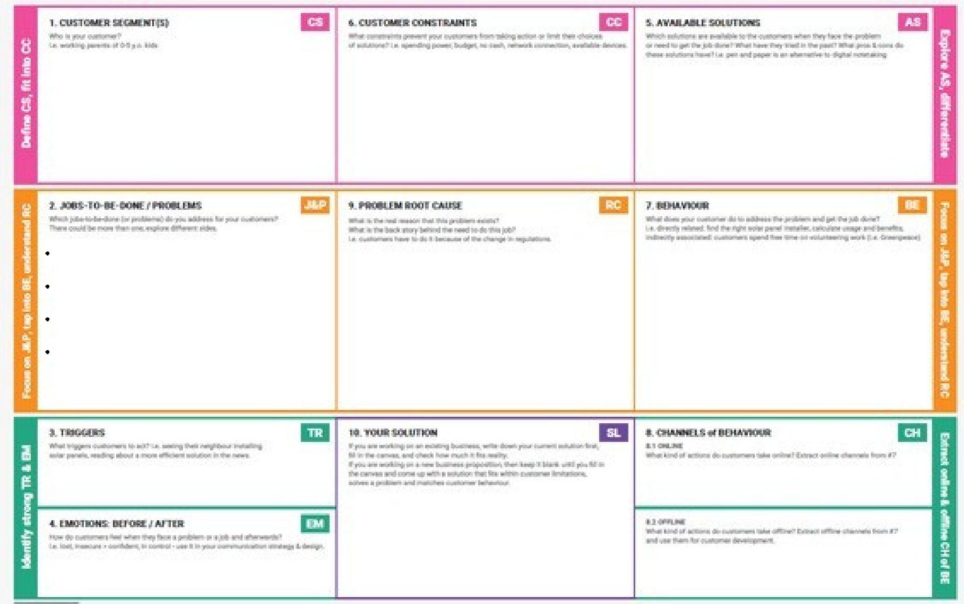

Lack of visual, easy-to-digest data on real estate markets

Inability to compare housing features and their effect on price

Hard to predict market fluctuations

Seeing peers using real estate dashboards

Urban planning initiatives

Before: Confused, unsure, overwhelmed with raw data

After: Informed, confident, in control of buying/investment decisions

Raw housing data is available but not understandable

Lack of data visualization skills in common users

Gap between data availability and actionable insights

A Tableau dashboard that visually analyzes housing sale prices and features

Dynamic filters to compare prices by area, size, year, number of rooms, etc.

Manually compare listings Consult agents

Rely on outdated reports

Use basic filters on property websites Ask peers for opinions

Tableau dashboards shared on blogs or LinkedIn

Broker consultations Real estate expos